
American International University- Bangladesh (AIUB) Faculty of Engineering (FE)

Course Name: | DATA COMMUNICATION | Course Code: | COE3103
Semester: | Spring 2024-25 | Section: | L
Faculty: | DR. AMIRUL ISLAM | Group: | 08
Experiment No: | 04
Experiment Name: | Study of Digital to Digital Conversion (Line Coding) Using MATLAB

Submitted by (NAME): | HOSSAIN MOHAMMAD SAMI | Student ID: | 23-51354-1
Group Members |  | Name | ID
 | 1. | MD. MIRAN HOSSAIN | 22-46175-1
 | 2. | FAHMIDA RAHMAN | 22-48483-3
 | 3. | MD. YEAHYEA JAM | 23-50187-1
 | 4. | MOHSIN IBNA HOSSAIN | 23-50194-1
 | 5. | HOSSAIN MOHAMMAD SAMI | 23-51354-1

Performance Date: | 23/03/2025 | Due Date: | 07/04/2025
Marking Rubrics (to be filled by Lab Instructor)
Category | Proficient [6] | Good [4] | Acceptable [2] | Unacceptable [1] | Secured Marks
Theoretical Background, Methods & procedures sections | All information, measures and variables are provided and  explained. | All Information provided is sufficient, but more explanation is  needed. | Most information is correct, but some information may be  missing or inaccurate. | Much information is missing and/or inaccurate.
Results | All of the criteria are met; results are described clearly and accurately; | Most criteria are met, but there may be some lack of clarity and/or incorrect information. | Experimental results don’t match exactly with the theoretical values and/or analysis  is unclear. | Experimental results are missing or incorrect;
Discussion | Demonstrates thorough and sophisticated understanding.  Conclusions drawn are appropriate for  analyses; | Hypotheses are clearly stated, but some concluding statements not supported by data or data not well  integrated. | Some hypotheses missing or misstated; conclusions not supported by data. | Conclusions don’t match hypotheses, not supported by data; no integration of data from different sources.
General formatting | Title page, placement of figures and figure captions, and other  formatting issues all correct. | Minor errors in formatting. | Major errors and/or missing information. | Not proper style in text.
Writing & organization | Writing is strong and easy to understand; ideas are fully elaborated and connected; effective transitions between sentences; no  typographic, spelling, or grammatical errors. | Writing is clear and easy to understand; ideas are connected; effective transitions between sentences; minor typographic, spelling, or grammatical errors. | Most of the required criteria are met, but some lack of clarity, typographic, spelling, or grammatical errors are present. | Very unclear, many errors.
Comments: |  |  |  | Total Marks (Out of 30):

Title
Study of Digital-to-Digital Conversion (Line Coding) Using MATLAB
Abstract
This experiment is designed to-
1.To understand the use of MATLAB for solving communication engineering problems.
2.To develop understanding of Digital to Digital Conversion (Line Coding) using MATLAB.

Introduction
Line Coding: The conversion of digital data into digital signals is known as line coding. We presume that information is stored in computer memory as a series of bits, whether it be text, numbers, graphical pictures, audio, or video. A digital signal is created from a series of bits via line coding. Digital data is encoded into a digital signal at the transmitter, and the digital signal is decoded at the receiver to reproduce the digital data. The procedure is depicted in Figure 1.
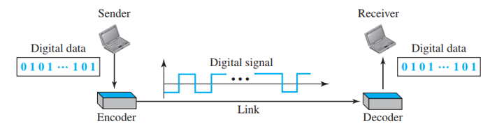
Figure 1: Line Coding and Decoding

Signal and Data Elements: Let's examine the differences between signal and data elements. Sending data components is the aim of data communications. The smallest thing that can represent a bit of information is called a data element. Data elements are carried by signal elements in digital data transfers. The smallest unit of a digital signal in terms of time is called a signal element. To put it another way, signal elements are what we may communicate, and data elements are what we must send.
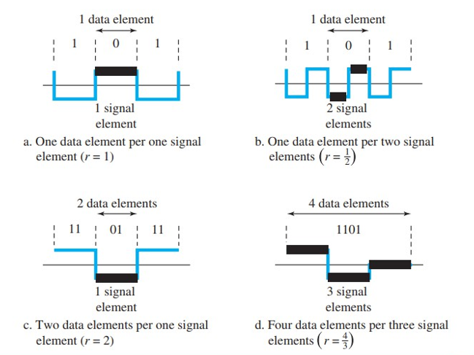
Figure 2: Signal vs Data elements
Bandwidth: A digital signal carrying information is known to be nonperiodic. We also know that a nonperiodic signal has an unlimited range and a constant bandwidth. The majority of digital signals that we come across in real life, however, have a limited bandwidth. To put it another way, even if the bandwidth is theoretically unlimited, many of the components are so microscopic that they may be disregarded. It has a limited effective bandwidth. Going forward, it is important to keep in mind that this effective bandwidth is being discussed whenever the bandwidth of a digital transmission is discussed.

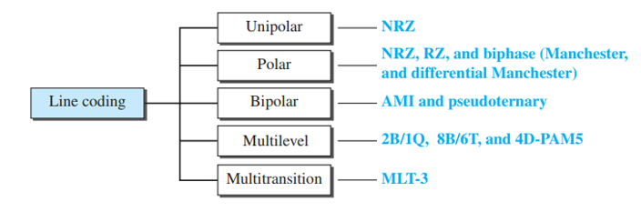
Different Line Coding Schemes:-
Figure 3 Line coding schemes

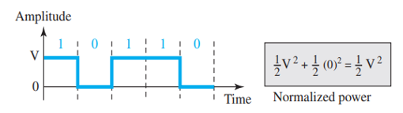
Unipolar: -
Figure 4: Unipolar NRZ scheme

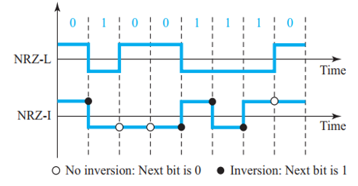
Polar: -
Figure 5: Polar NRZ-L and NRZ-I schemes

Polar Biphase:-
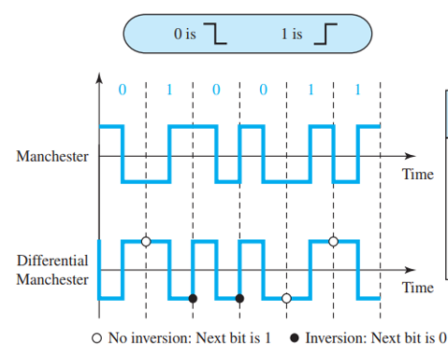
Figure 6: Manchester and differential Manchester schemes
Bipolar: -
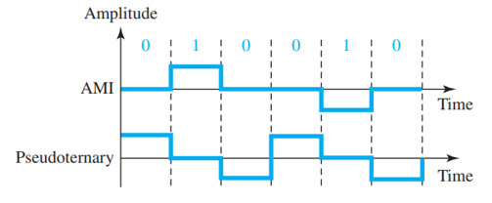
Figure 7: AMI and pseudoternary

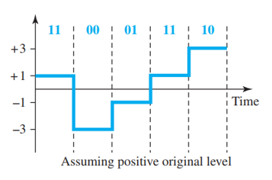
Multilevel: - To enhance data rates or reduce bandwidth usage, various encoding schemes have been developed. The main idea is to increase the number of bits transmitted per baud by mapping a sequence of m data elements into n signal elements. Since data elements consist of only 0s and 1s, there are 2m possible data combinations. By utilizing multiple signal levels (L), we can generate Ln different signal patterns. When 2m = Ln each data pattern directly corresponds to a unique signal pattern. If 2m < Ln, only a selected subset of signal patterns is used, allowing for better synchronization, baseline wandering prevention, and error detection. However, if 2m > Ln some data patterns cannot be encoded, making transmission infeasible.
Figure 8: 2B1Q scheme

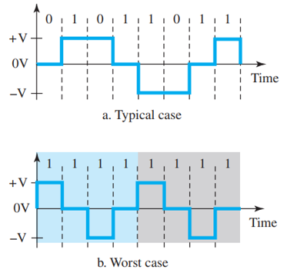
MLT-3:-
Figure 9: Multitransitional scheme

Results and Discussion
(a) Polar NRZ-L assuming bit rate is 4 kbps.
Code:
clc;
clear;

%// Define 12-bit bit stream
bit_stream = [0 1 0 1 0 1 1 0 0 1 1 1];
no_bits = length(bit_stream);
bit_rate = 4000; %// 4 kbps
pulse_per_bit = 1; %// 1 pulse per bit
pulse_duration = 1 / ((pulse_per_bit) * (bit_rate));
samples_per_pulse = 500;
fs = samples_per_pulse / pulse_duration; %// Sampling frequency
t = 0:1/fs:(no_bits * pulse_duration); %// Time vector
no_samples = length(t); %// Total samples

%// Initialize digital signal
dig_sig = zeros(1, no_samples);
max_voltage = 5;
min_voltage = -5;

%// Generate Polar NRZ-L Signal
for i = 1:no_bits
start_idx = (i - 1) * samples_per_pulse + 1;
end_idx = i * samples_per_pulse;

if bit_stream(i) == 1
dig_sig(start_idx:end_idx) = max_voltage; %// '1' ? +5V
else
dig_sig(start_idx:end_idx) = min_voltage; %// '0' ? -5V
end
end

%// Plot the waveform
plot(t, dig_sig, 'linewidth', 1.5);
grid on;
xlabel('Time (seconds)');
ylabel('Voltage (V)');
ylim([min_voltage - 2, max_voltage + 2]);
title('Polar NRZ-L Digital Signal');

Result and Discussion:
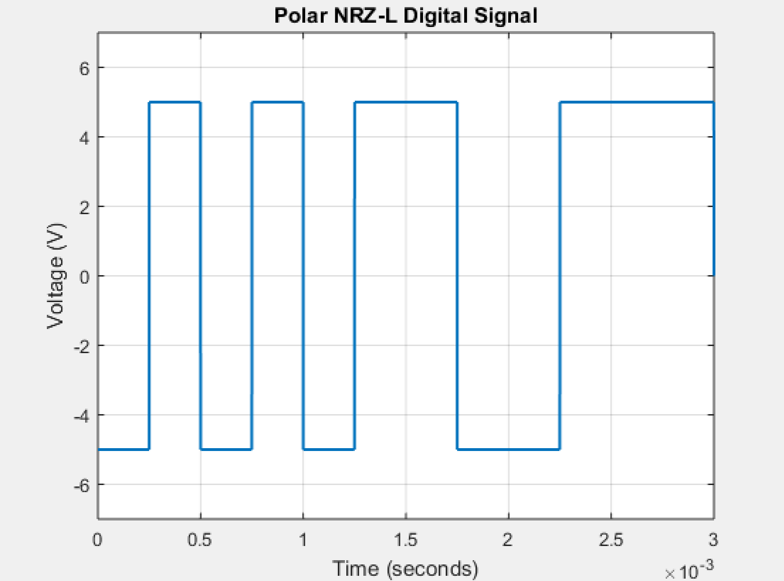
Fig10: Polar NRZ-L Signal
• In this scheme, a logical '1' is represented by a positive voltage and a logical '0' by a negative voltage.
• The waveform clearly shows that there is no transition unless the bit changes.
• It provides a simple and efficient way of line coding but suffers from DC component issues and baseline wandering.

(b) Manchester assuming bit rate is 2 kbps.
Code:
clc;
clear all;
close all;

%// Define 12-bit bit stream
bit_stream = [0 1 0 1 0 1 1 0 0 1 1 1];
no_bits = length(bit_stream);
bit_rate = 2000; %// 2 kbps
pulse_duration = 1 / bit_rate; %// Duration of one bit
samples_per_pulse = 500;
fs = samples_per_pulse / pulse_duration; %// Sampling frequency
t = 0:1/fs:(no_bits * pulse_duration); %// Time vector
no_samples = length(t);

%// Initialize Manchester encoded signal
manchester_sig = zeros(1, no_samples);
max_voltage = 5;
min_voltage = -5;

%// Generate Manchester Encoded Signal
for i = 1:no_bits
start_idx = (i - 1) * samples_per_pulse + 1;
mid_idx = start_idx + samples_per_pulse / 2;
end_idx = i * samples_per_pulse;

if bit_stream(i) == 0
%// '0' ? High to Low transition (5V ? -5V)
manchester_sig(start_idx:mid_idx) = max_voltage;
manchester_sig(mid_idx+1:end_idx) = min_voltage;
else
%// '1' ? Low to High transition (-5V ? 5V)
manchester_sig(start_idx:mid_idx) = min_voltage;
manchester_sig(mid_idx+1:end_idx) = max_voltage;
end
end

%// Plot the waveform
plot(t, manchester_sig, 'linewidth', 1.5);
grid on;
xlabel('Time (seconds)');
ylabel('Voltage (V)');
ylim([min_voltage - 2, max_voltage + 2]);
title('Manchester Encoded Digital Signal');

Result and Discussion:
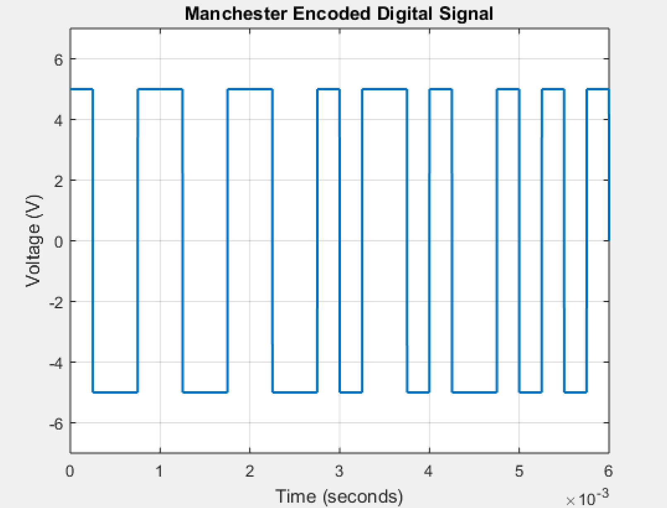
Fig11: Manchester Encoded Signal

• Each bit has a transition in the middle, making clock synchronization easier.
• '0' is represented by a high-to-low transition, while '1' is represented by a low-to-high transition.
• The self-clocking nature helps in reducing synchronization issues, but it requires twice the bandwidth compared to NRZ.

(c) AMI assuming bit rate is 5 kbps.
Code:
clc;
clear all;
close all;

%// Define 12-bit bit stream
bit_stream = [0 1 0 1 0 1 1 0 0 1 1 1];
no_bits = length(bit_stream);
bit_rate = 5000; %// 5 kbps
pulse_duration = 1 / bit_rate; %// Duration of one bit
samples_per_pulse = 500;
fs = samples_per_pulse / pulse_duration; %// Sampling frequency
t = 0:1/fs:(no_bits * pulse_duration); %// Time vector
no_samples = length(t);

%// Initialize AMI encoded signal
ami_sig = zeros(1, no_samples);
max_voltage = 5;
min_voltage = -5;
current_polarity = max_voltage; %// First '1' should be +5V

%// Generate AMI Encoded Signal
for i = 1:no_bits
start_idx = (i - 1) * samples_per_pulse + 1;
end_idx = i * samples_per_pulse;

if bit_stream(i) == 1
ami_sig(start_idx:end_idx) = current_polarity; %// Assign polarity
current_polarity = -current_polarity; %// Alternate polarity
else
ami_sig(start_idx:end_idx) = 0; %// '0' is always 0V
end
end

%// Plot the waveform
plot(t, ami_sig, 'linewidth', 1.5);
grid on;
xlabel('Time (seconds)');
ylabel('Voltage (V)');
ylim([min_voltage - 2, max_voltage + 2]);
title('AMI (Alternate Mark Inversion) Encoded Digital Signal');

Result and Discussion:
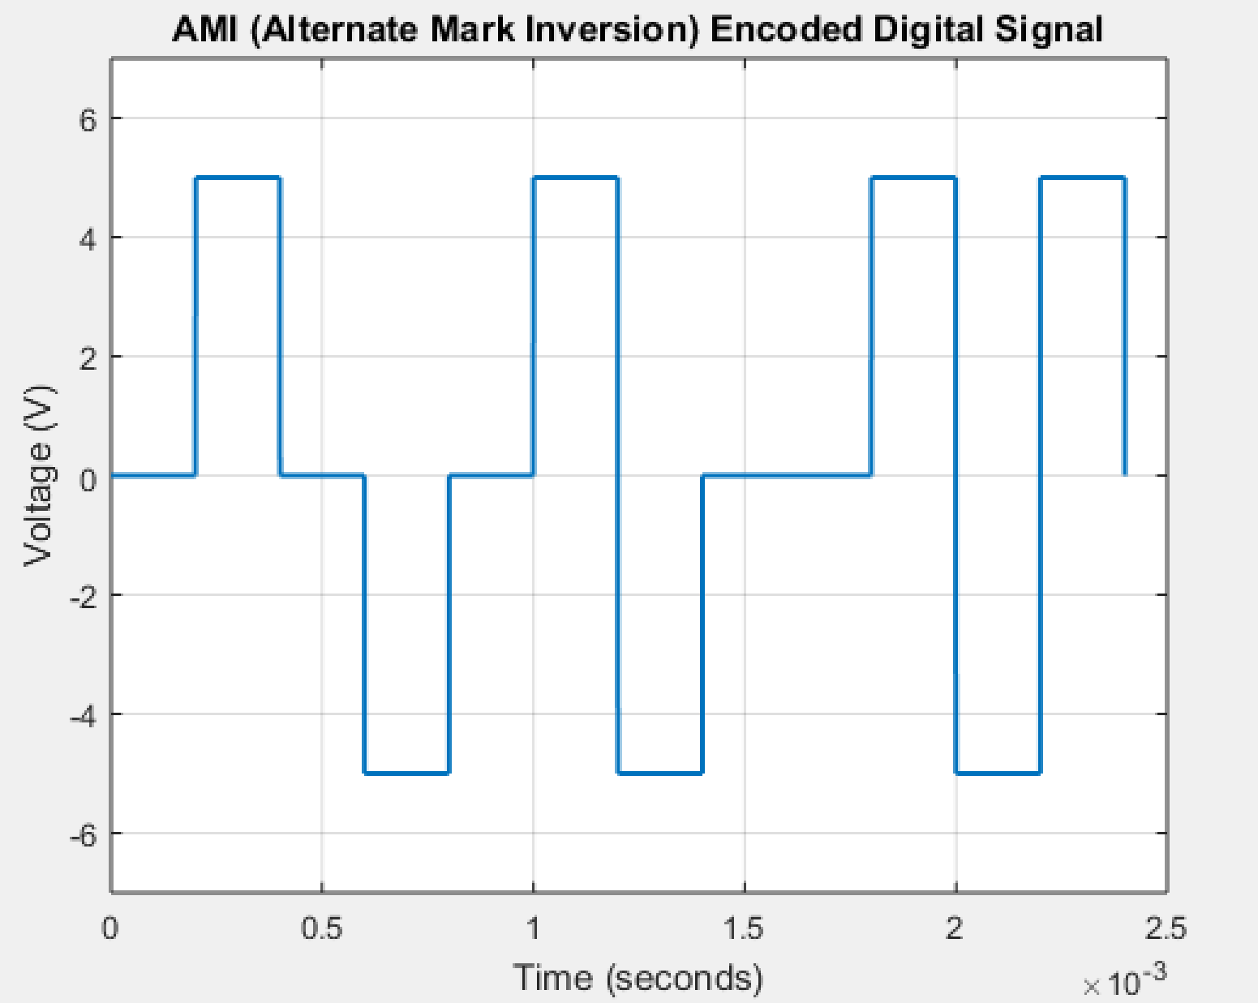
Fig12: AMI Encoded Signal
- In this scheme, '0' is represented as zero voltage, and '1' alternates between positive and negative voltages.
- It prevents baseline wandering and has no DC component, making it suitable for long-distance transmission.
- However, long sequences of '0's may cause synchronization issues.

(d) MLT-3 assuming bit rate is 10 kbps.
Code:
clc;
clear all;
close all;

bit_rate = 10000;
bit_duration = 1 / bit_rate;
fs = 1000000;
samples_per_bit = fs * bit_duration; %// Samples per bit

%// Input bit sequence
bit_str = '010101100111';
bit_sequence = (bit_str == '1'); %// Convert to logical array

%// MLT-3 encoding logic
current_level = 0; %// Start at 0 level
direction = 1; %// Initial direction

%// Initialize signal
total_bits = length(bit_sequence);
total_samples = total_bits * samples_per_bit;
signal = zeros(1, total_samples);
time = linspace(0, total_bits * bit_duration, total_samples);

%// Generate MLT-3 signal
for i = 1:total_bits
bit = bit_sequence(i);
if bit
if current_level == 0
new_level = direction * 1; %// Transition to +1 or -1
direction = -direction; %// Toggle direction
else
new_level = 0; %// Transition back to 0
end
else
new_level = current_level; %// No change for '0'
end

start_idx = (i-1)*samples_per_bit + 1;
end_idx = i * samples_per_bit;
signal(start_idx:end_idx) = new_level;

current_level = new_level; %// Update level
end

%// Plot the signal
figure;
plot(time, signal, 'LineWidth', 1.5);
ylim([-1.5 1.5]);
title('MLT-3 Encoded Signal');
xlabel('Time (s)');
ylabel('Voltage Level');
grid on;

Result and Discussion:
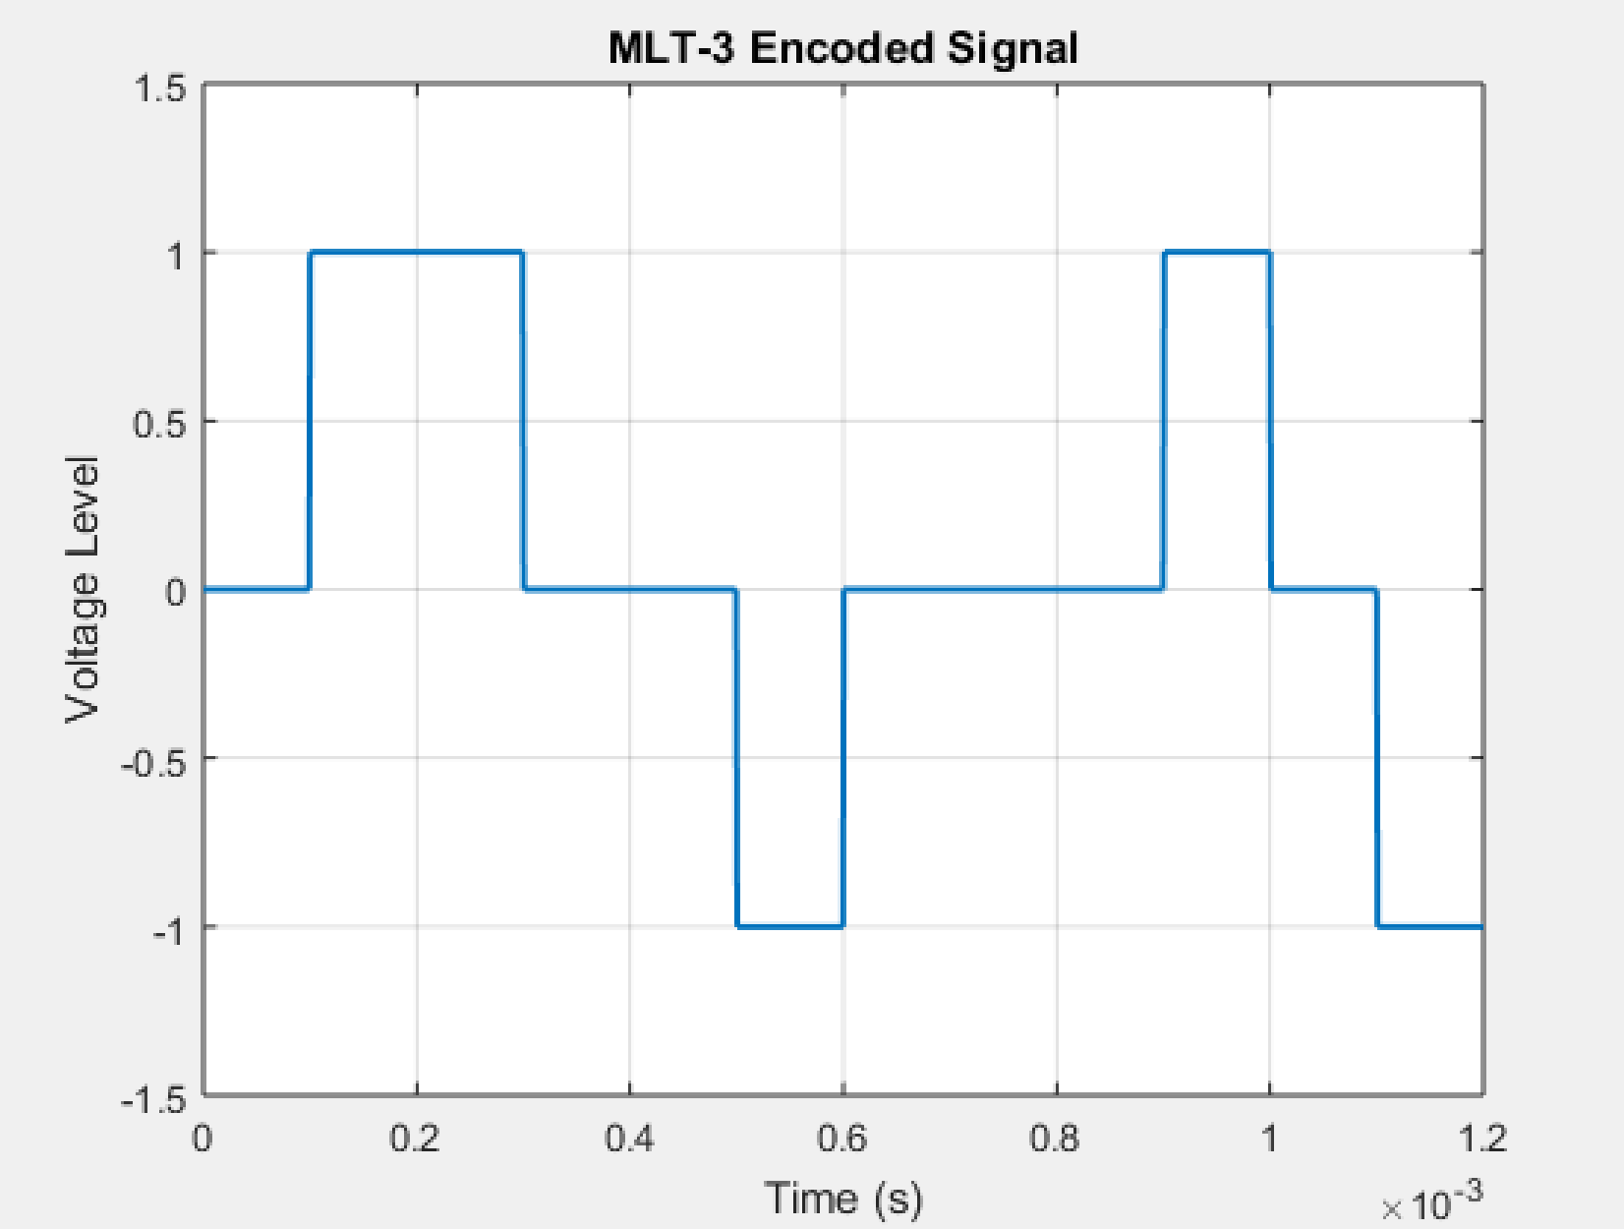
Fig13: MLT-3 signal
• Uses three voltage levels: +1, 0, and -1.
• It reduces bandwidth requirements by encoding data with a cyclic pattern of level transitions.
• It is efficient for high-speed data transmission but depends on previous states, making it slightly complex.

Conclusion
In this experiment, we successfully implemented and analyzed various digital-to-digital line coding schemes using MATLAB. Each coding scheme has unique characteristics and applications; for example, Manchester encoding ensures synchronization through mid-bit transitions, while AMI eliminates the DC component by alternating the polarity of '1's. MLT-3 efficiently reduces bandwidth requirements by cycling through three voltage levels. These techniques are essential in digital communication systems, where factors such as bandwidth efficiency, synchronization, and baseline wandering need to be considered. Understanding these coding methods provides valuable insights into designing reliable and efficient data transmission systems.

